Documentation Assignment (Individual)

Name: Tan Wen Tao Bryan

Student ID: p2214449

Class: DAAA/1A/01

Task 1:

Add a new account (Student ID)

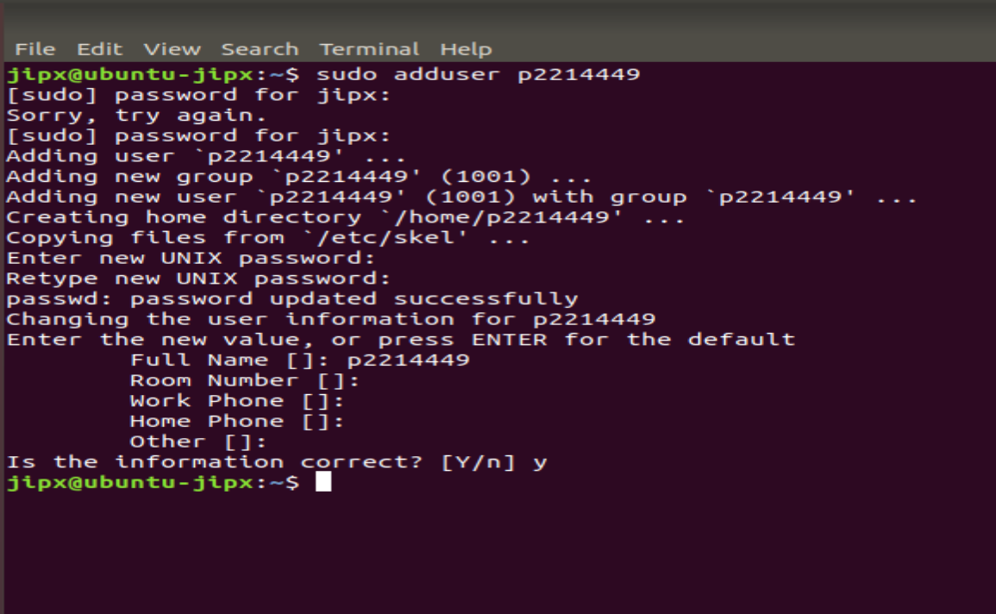



Edit the host files to put in my student ID.

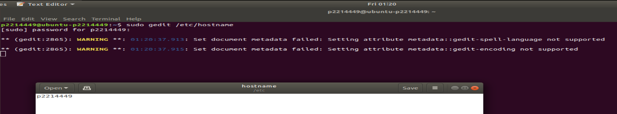

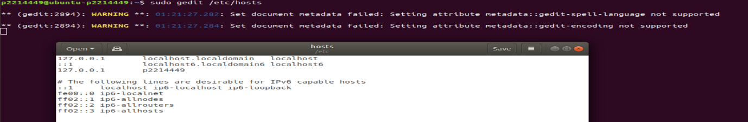

Edit the file /etc/netplan/50-cloud-init.yaml and change the renderer to NetworkManager.

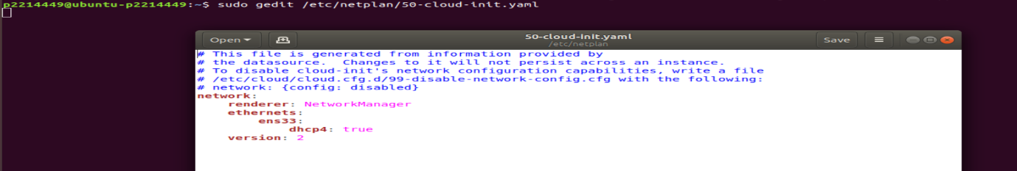

Apply updated changes

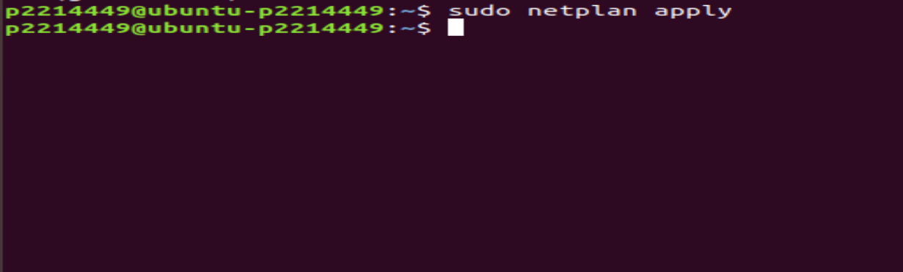

Task 2:

Update Ubuntu

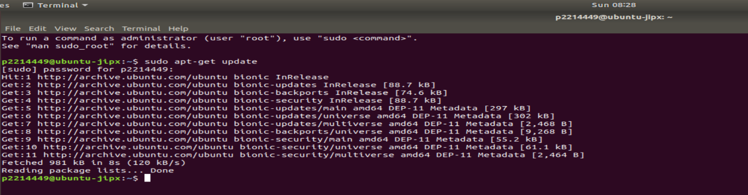

Install apache2 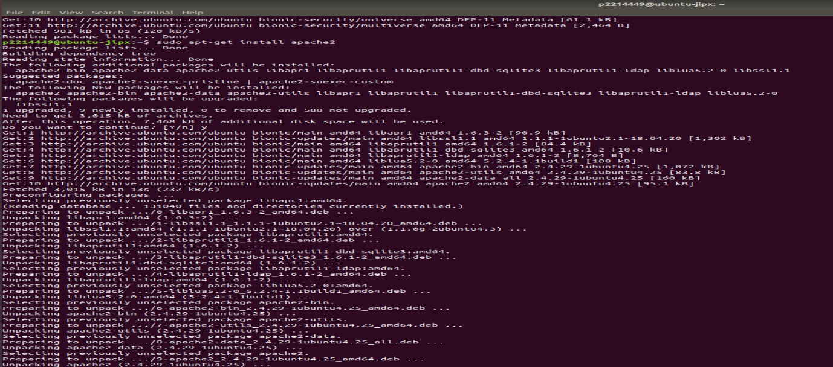

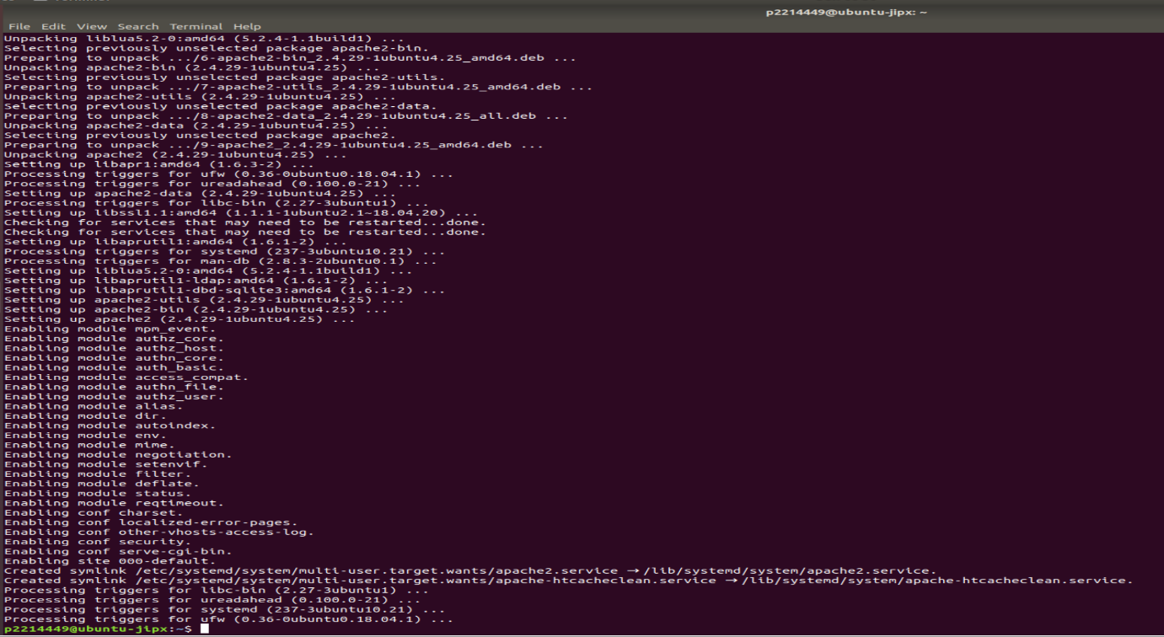

Check status of apache2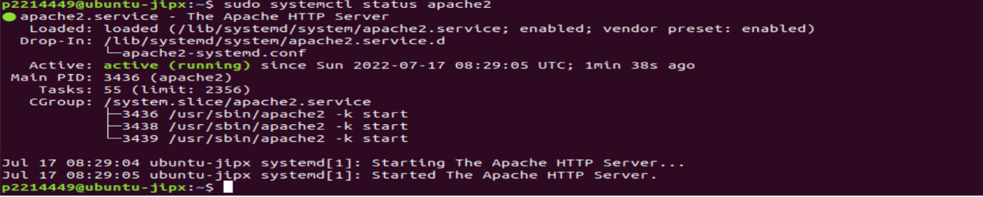

Check for your server IP address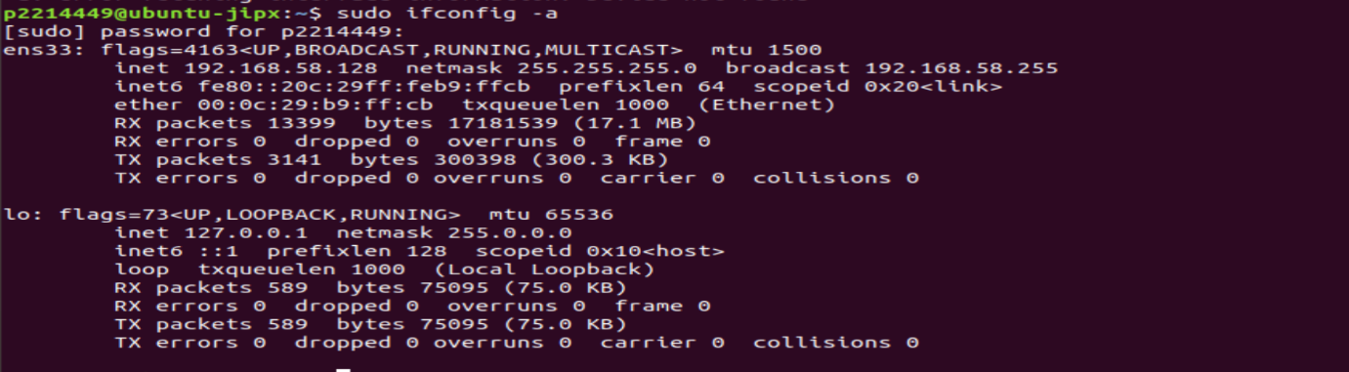

Check if apache2 is connected to the server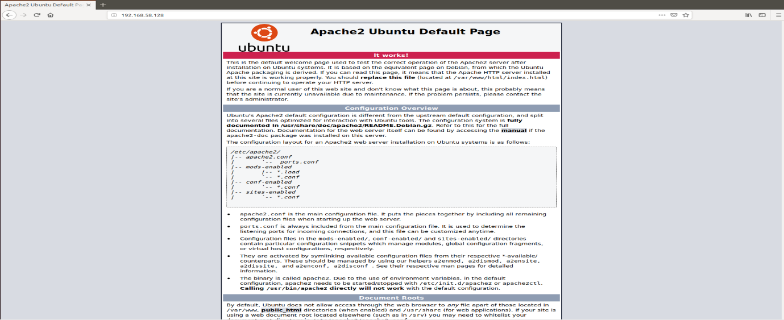

Install PHP and all required PHP commands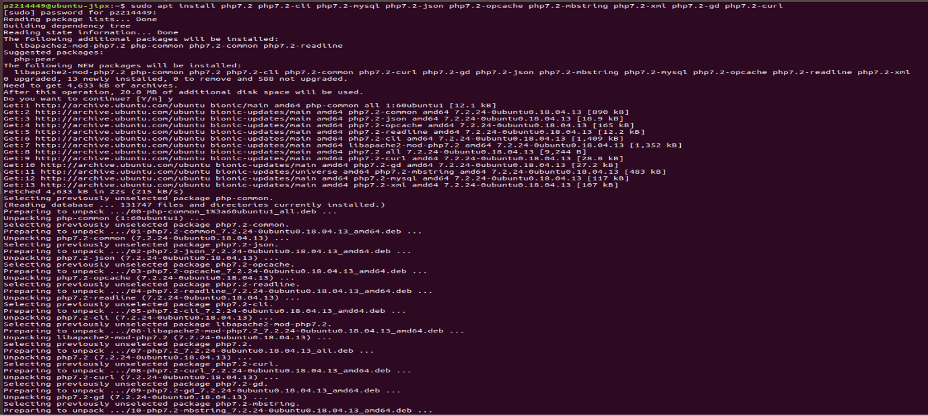

Restart apache2 so the newly installed PHP extensions are loaded



After typing sudo vi /var/www/html/test.php, add this in test.php as a test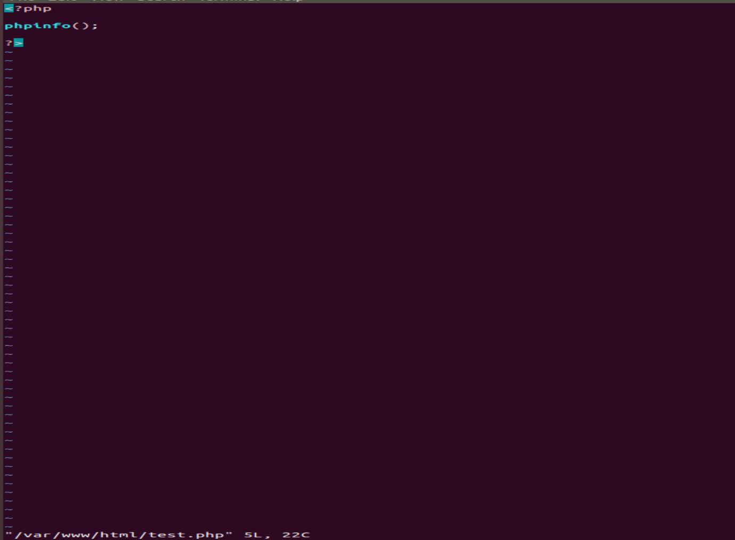

Test whether the web server can correctly display content generated by a PHP script

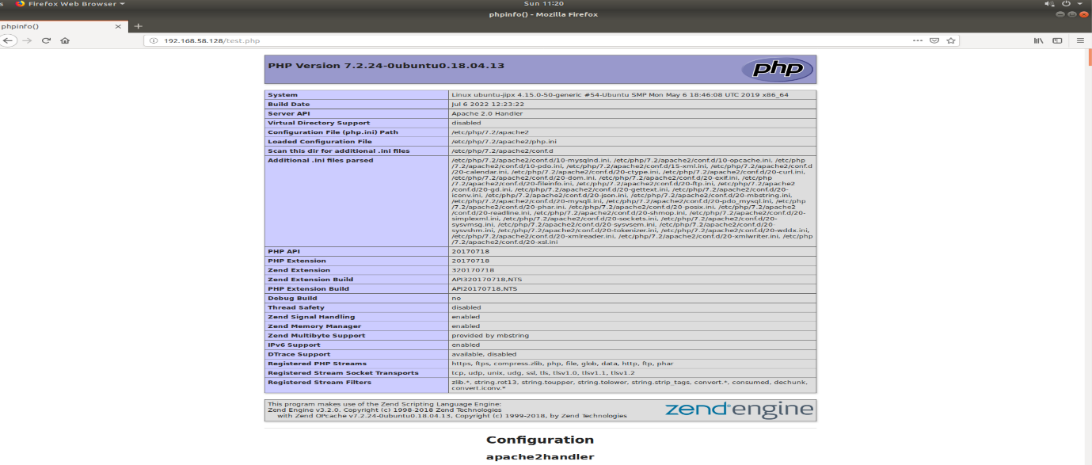

Update Ubuntu again to ensure latest version is installed

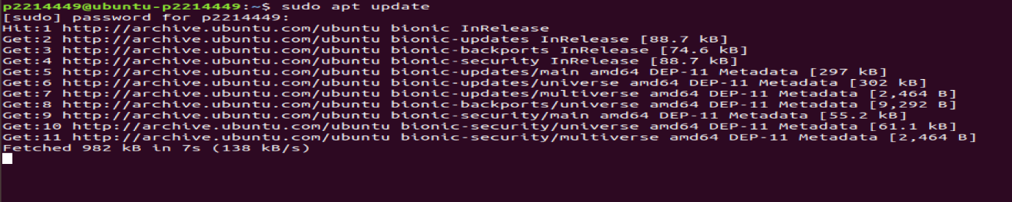

Install MySQL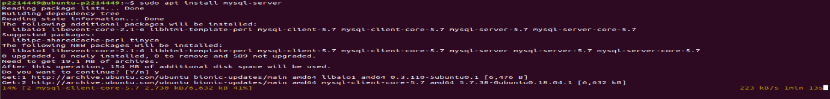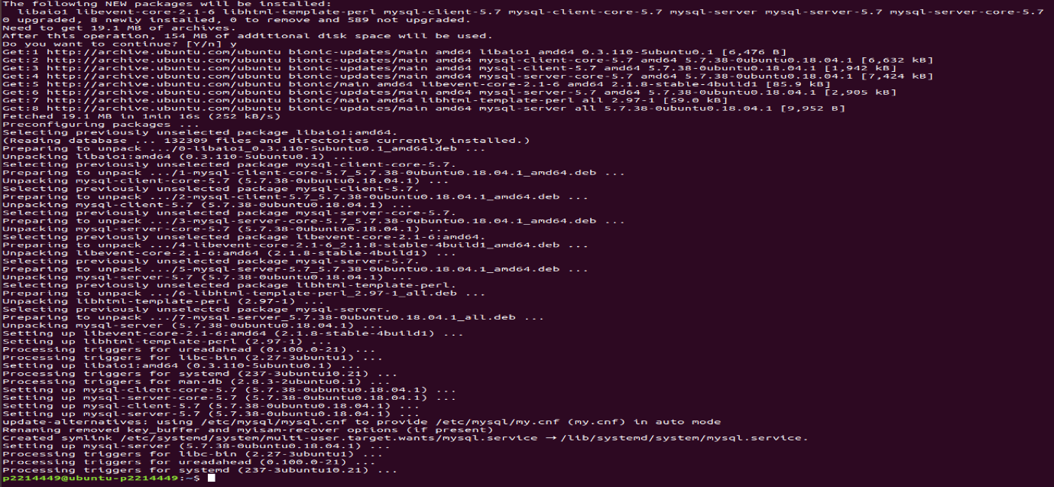

Run the security script for MySQL

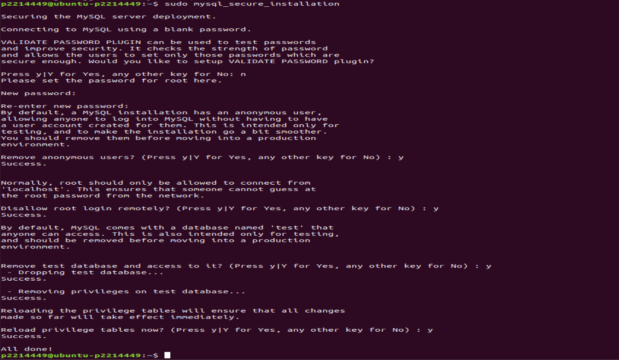

Task 3:

Add group sysadmin with a GID of 10000, using -g & verify that it exists

Add a new user, sysadminuser1, to sysadmin by using -g to add it to the same group as sysadmin. Use -m to create home directory and -u to create its UID. Verify that the user exists.

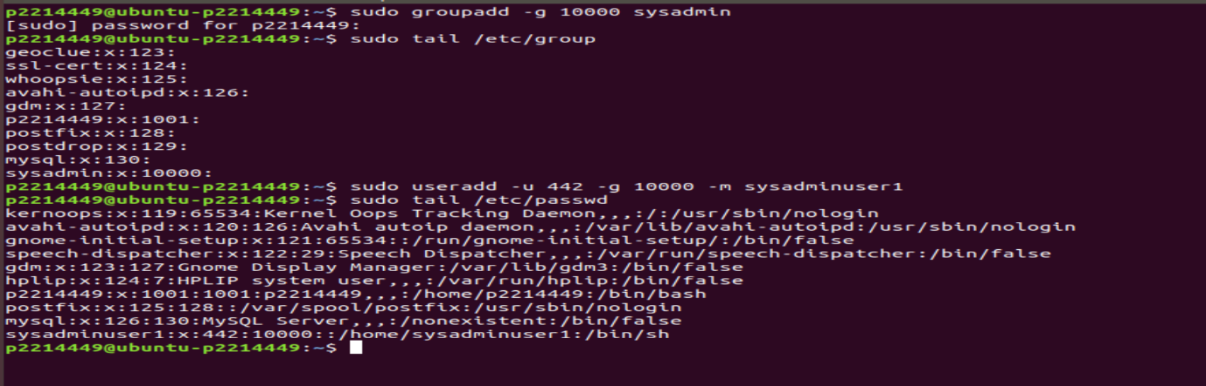

Add a new user, sysadminuser2, to sysadmin by using -g to add it to the same group as sysadmin. Use -m to create home directory and -u to create its UID. Verify that the user exists.

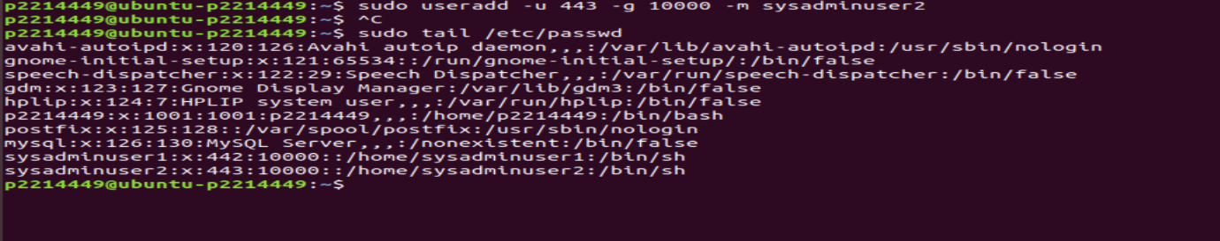

Give sysadminuser1 and sysadminuser2 sudo privileges. Check which groups sysadminuser1 and sysadminuser2 are under.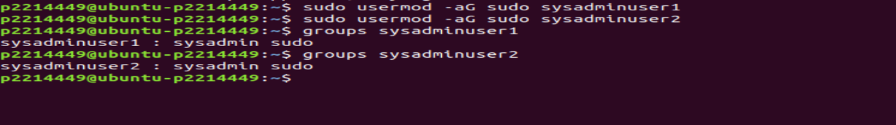

To be able to update and manage Ubuntu server, the sysadmin group must be given administrative rights of root user. Edit the sudoers file, sudo vi /etc/sudoers to allow sysadmin group to execute any command.

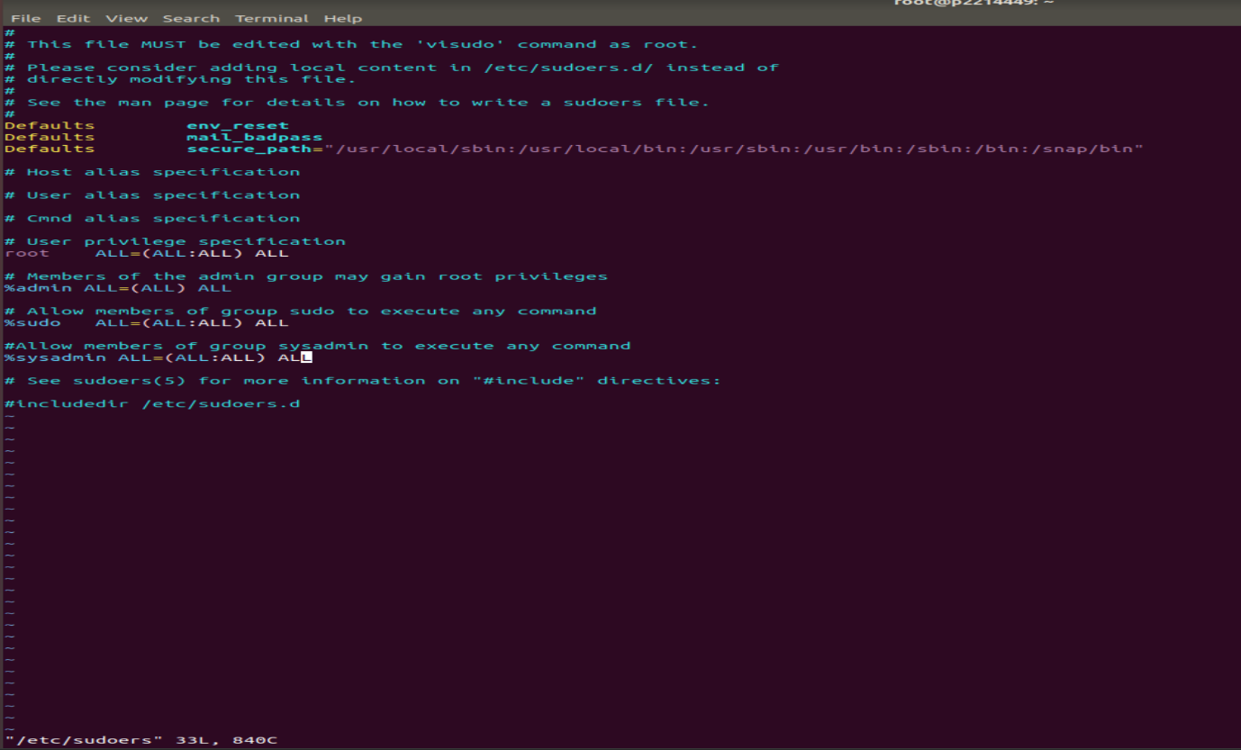

Add group webdev with a GID of 10100, using -g & verify that it exists.

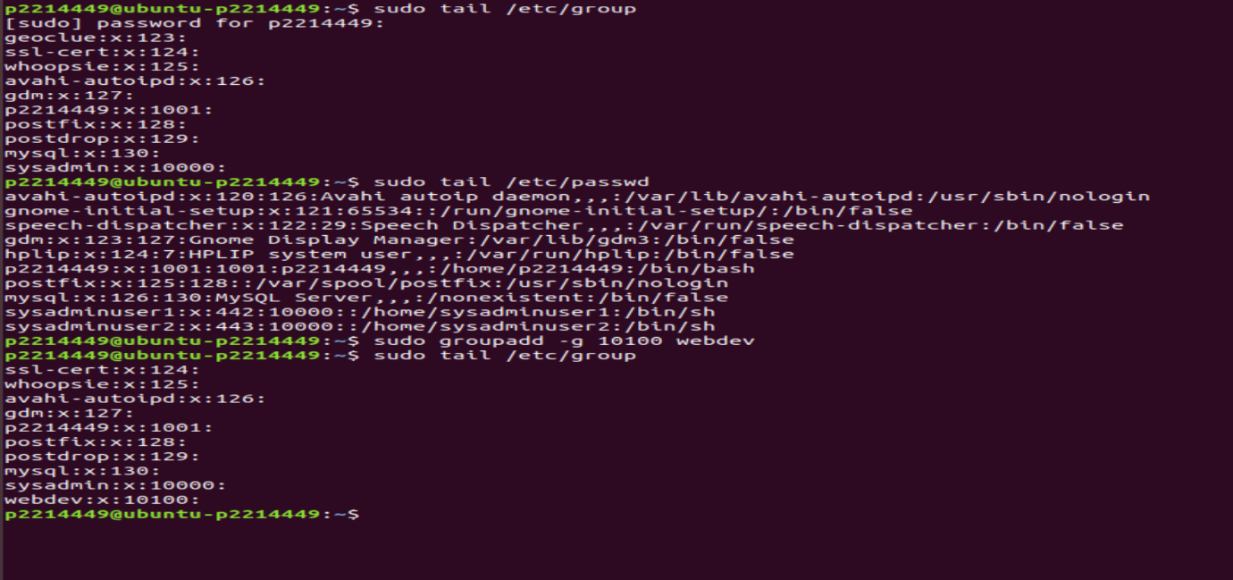

Add a new user webdevuser1 to webdev by using -g to add it to the same group as webdev. Use -m to create home directory and -u to create its UID. Verify that the user exists.

Do the same for webdevuser2.

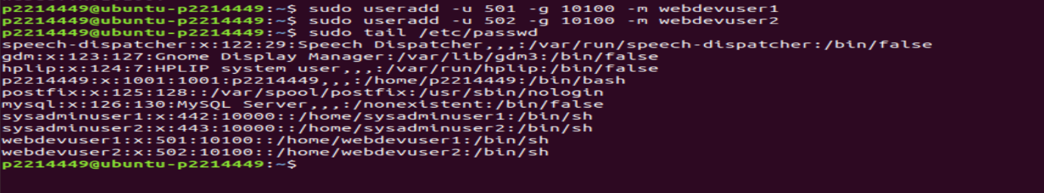

Check that the users webdevuser1 and webdevuser2 belong to webdev.

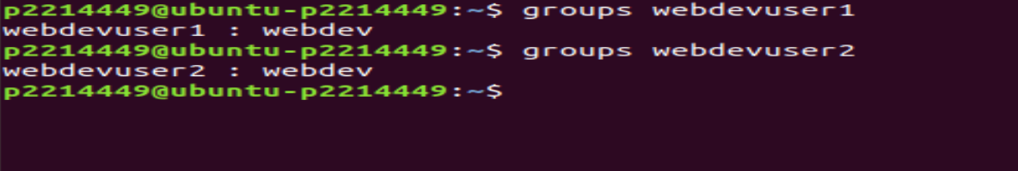

Passwords created for the different users in this VM:

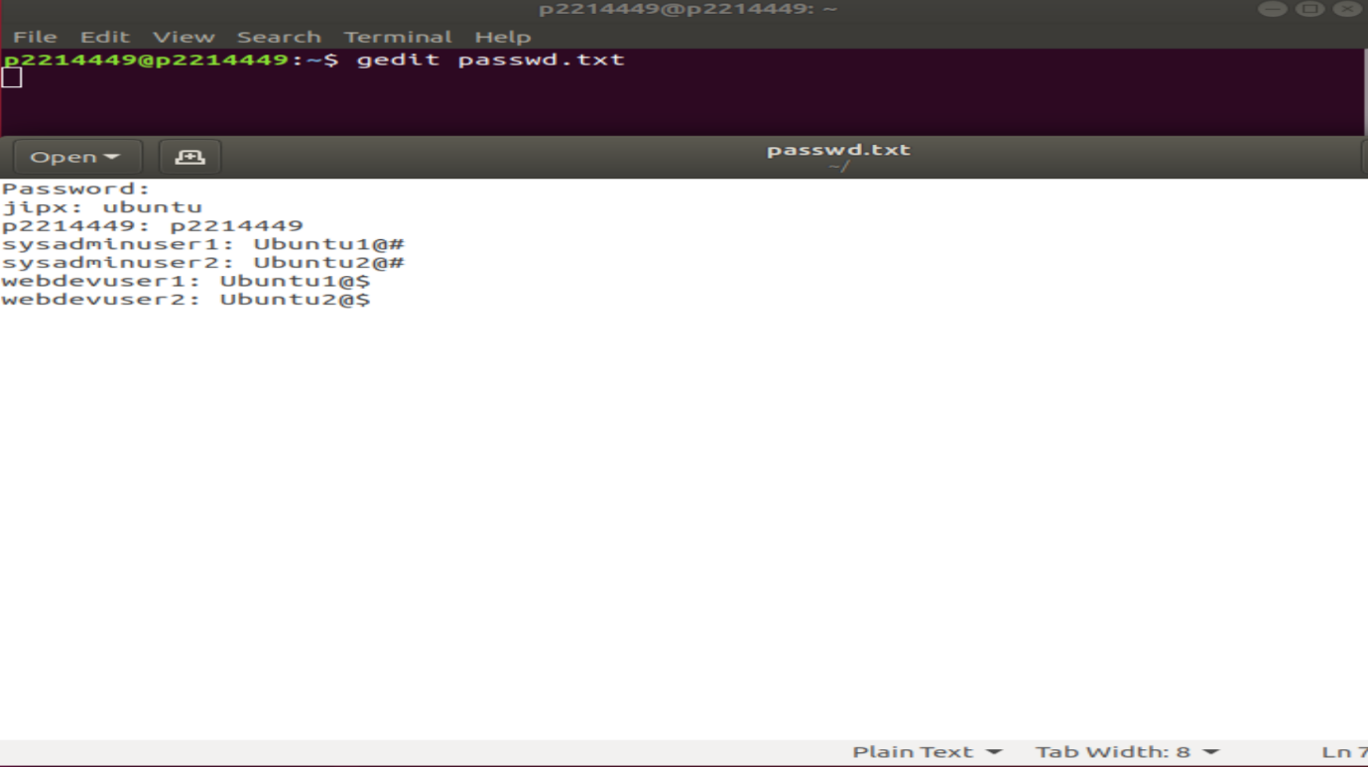

Create password for sysadminuser1, sysadminuser2, webdevuser1 and webdevuser2 so users can log in it.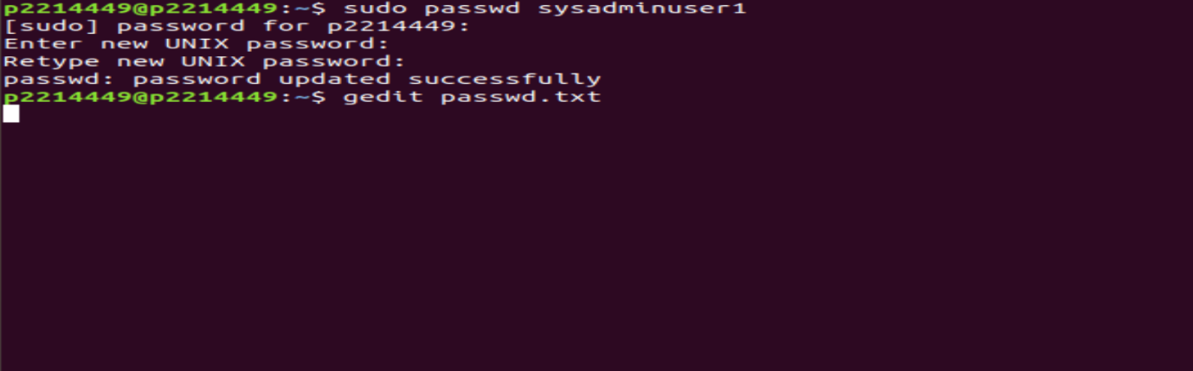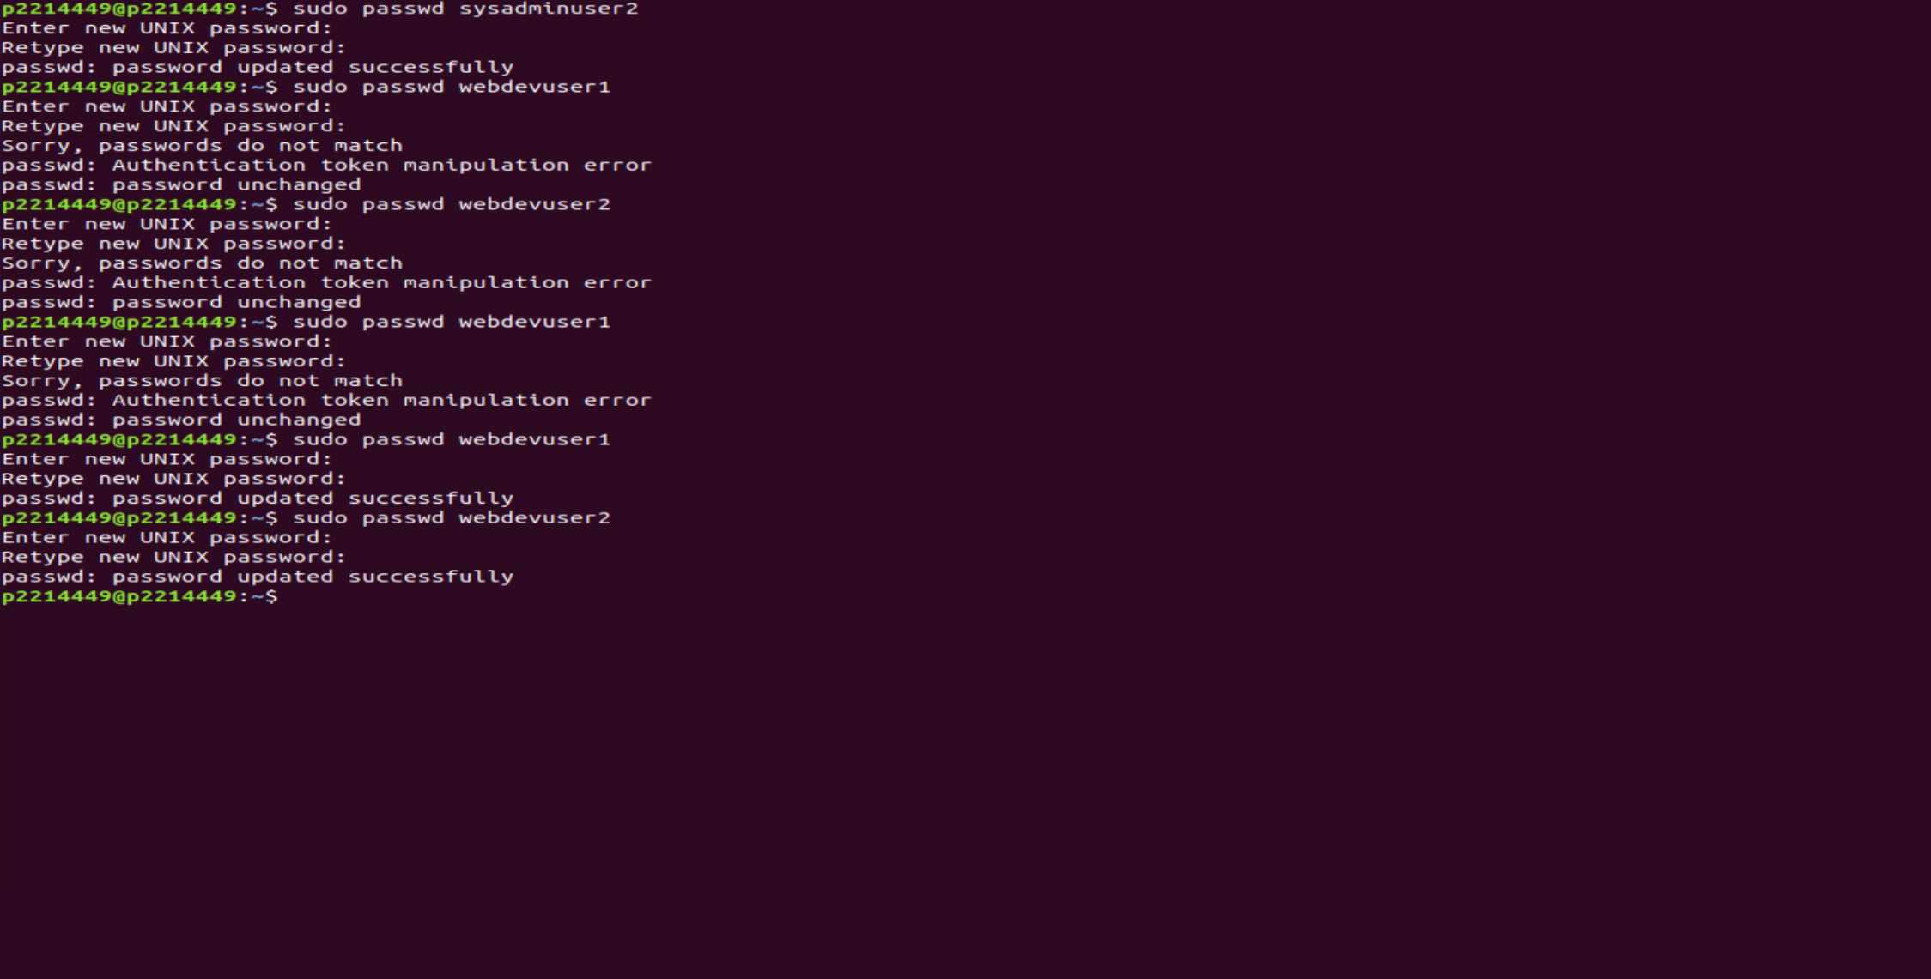

Verify that sysadminuser1 and sysadminuser2 are able to execute sudo commands, start and stop services.

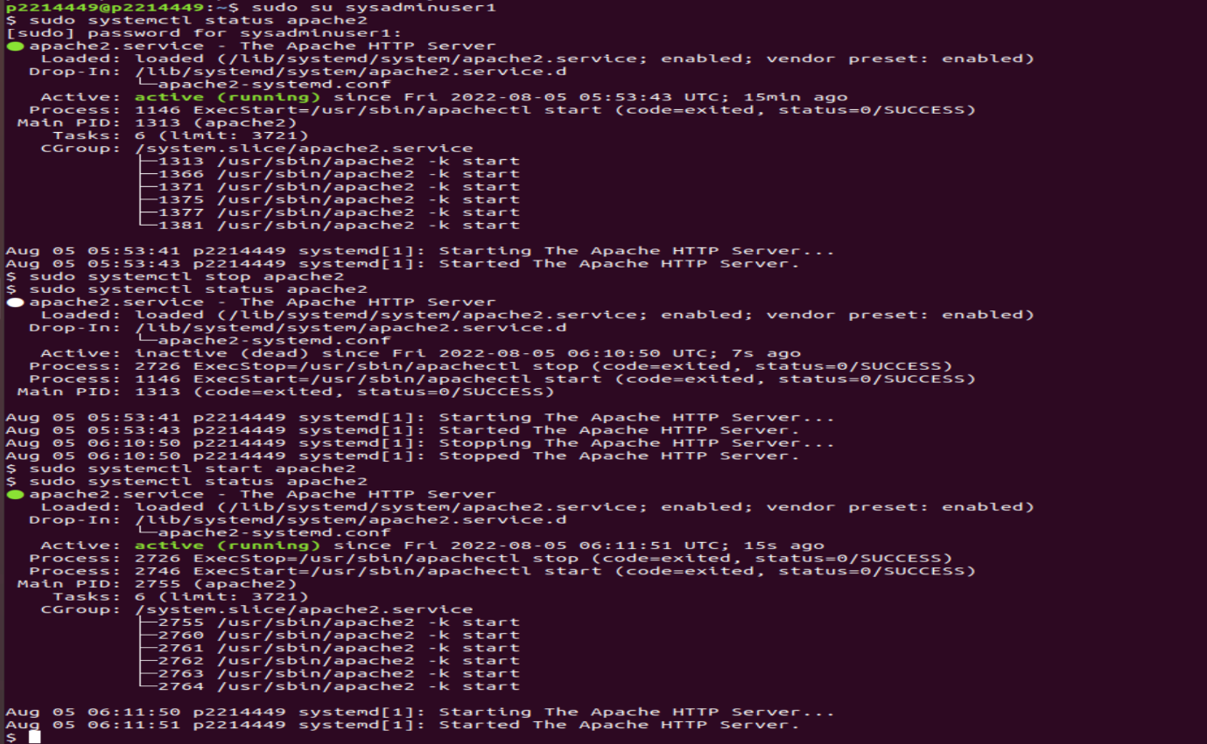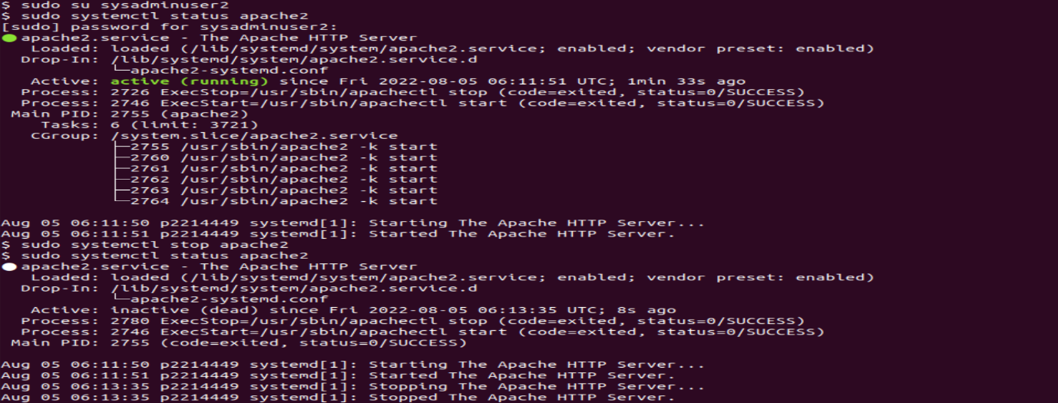

Task 4:

Login to MySQL server as MySQL root user.

Create a user and password in MySQL server for PHP application to access MySQL server.

Verify that the user is created.

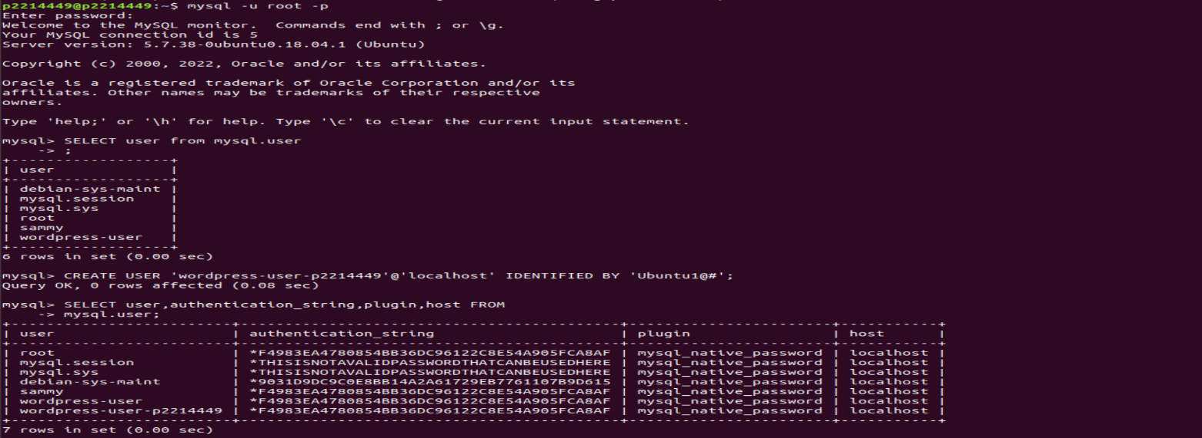

Create a database for Wordpress.

Grant full privileges for the database to the WordPress user that was created earlier.

FLUSH PRIVILEGES; to update the changes being applied then EXIT; to exit MySQL terminal.

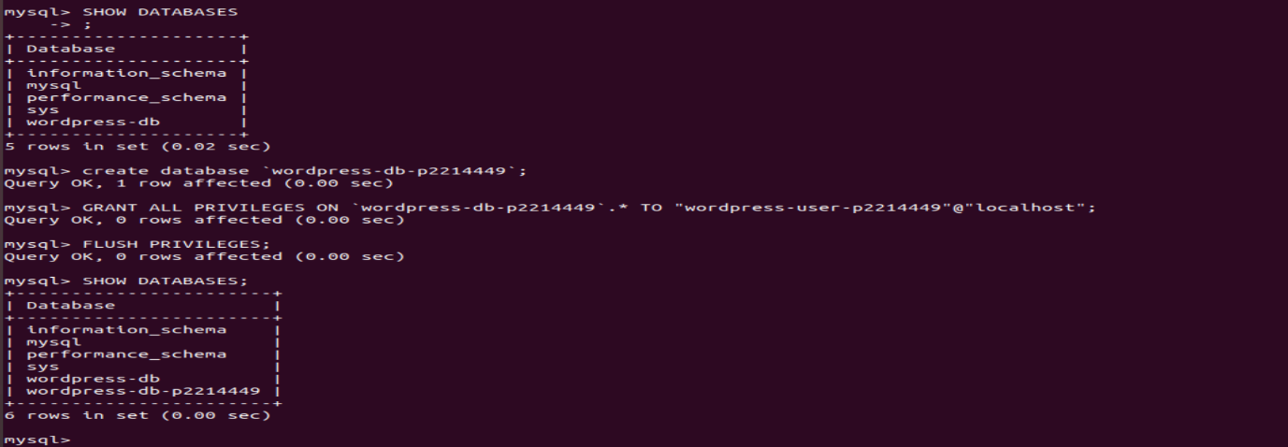

Change directory /etc/apache2/sites-available and edit the 000-default.conf file to configure the Apache web server.

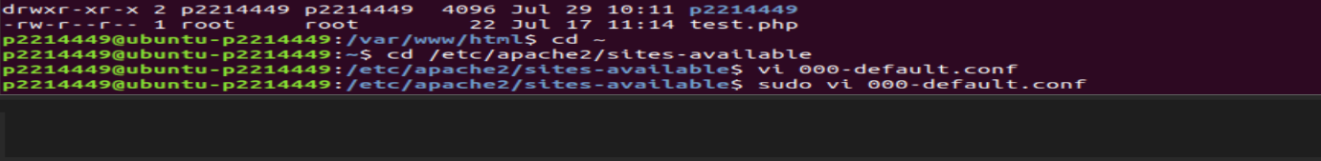

Set the document root in the 000-default.conf file to /var/www/html/(student_id) to configure the apache web server.

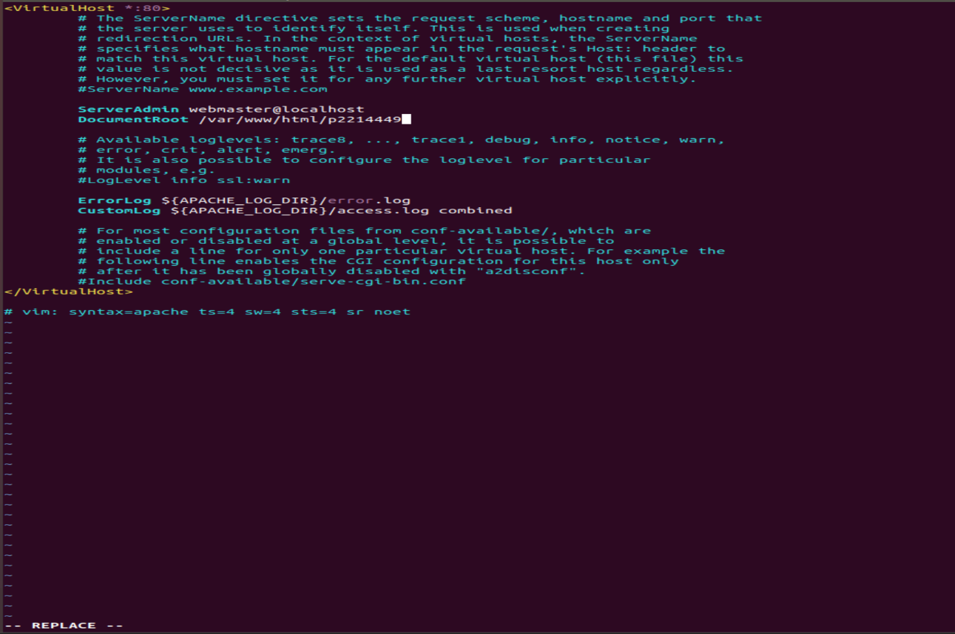

Change directory to /tmp and download the latest WordPress installation package with the wget command. It will always download the latest version.

Unzip and unarchive the installation package. The installation folder is unzipped to a

folder called WordPress.

Verify that the contents of WordPress had been installed and the installation folder has been extracted into the WordPress folder.

Copy the wp-config-sample.php file to a file called wp-config.php. This creates a new

configuration file and keeps the original sample file intact as a backup. 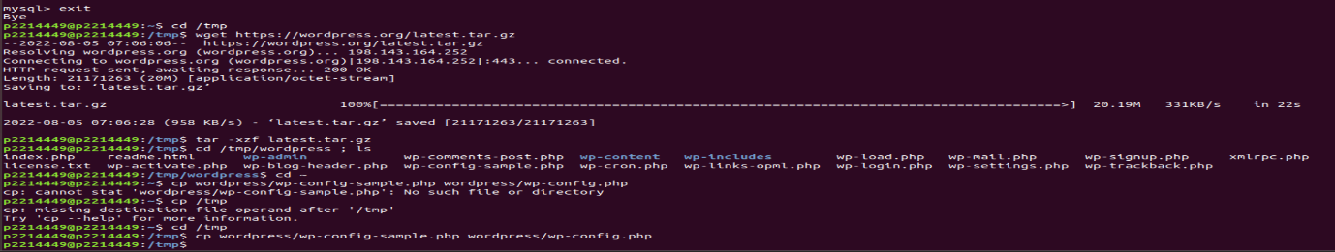

Edit the wp-config.php file with wordpress database and user information.

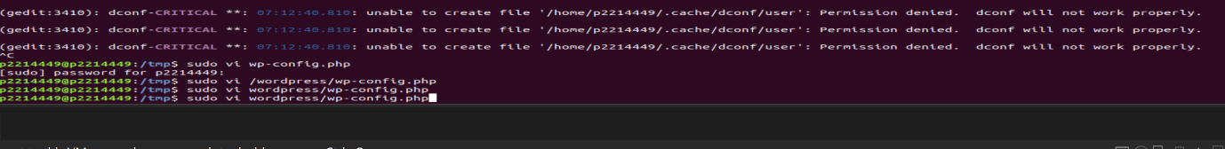

Add in the extra line define( `FS_METHOD’, ‘direct’ ); to allow WordPress to access the files directly.

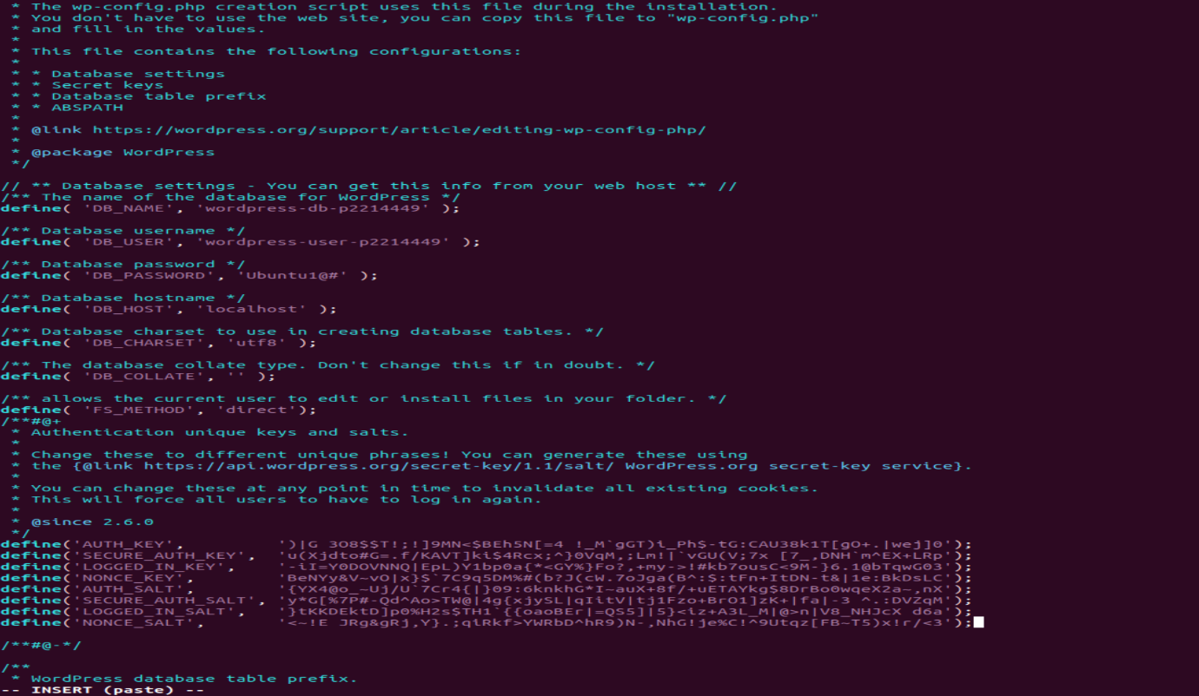

WordPress provides a secure generator to create these keys. These keys are pasted to provide security for installation as seen above.

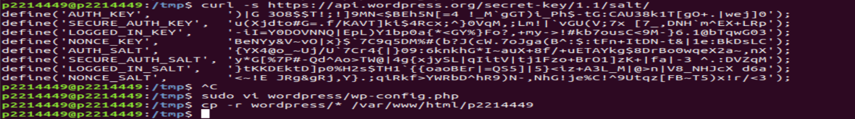

Copy all the WordPress files to our WordPress document root, which is /var/www/html/pXXXXXXX.

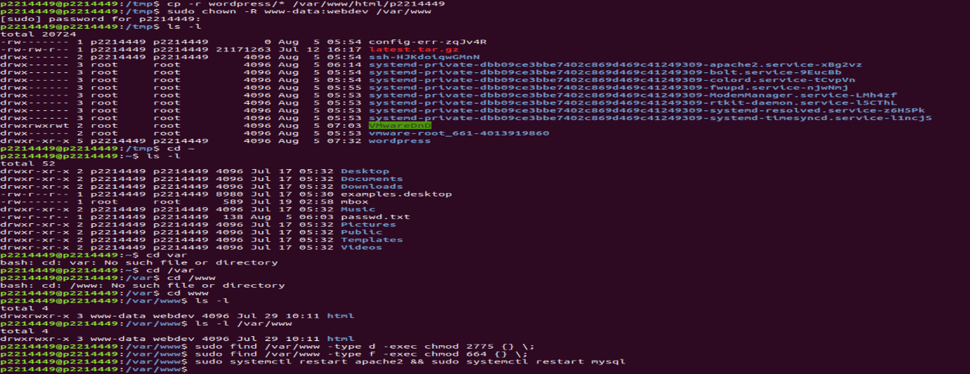

Set proper permissions for www-data system user, as well as webdev. Check the current file permissions for /var/www

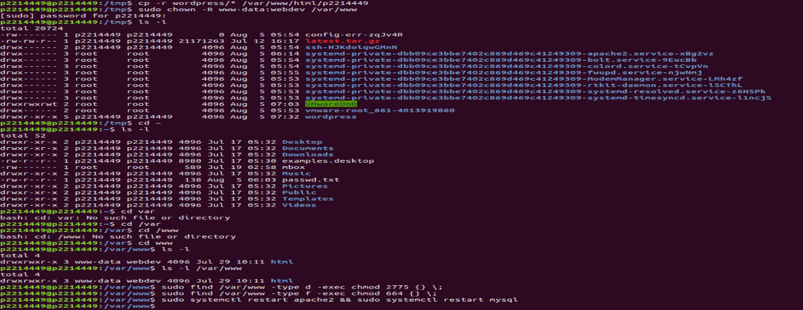

Set directory and file permissions of /var/www and its subdirectories. For directories, 2 to set gid ,7 rwx for owner and group, 5 r-x for others. For files, 6 rw- for owner and group, 4 r- - for others.

Restart the Apache2 web server and MySQL server after installing WordPress.

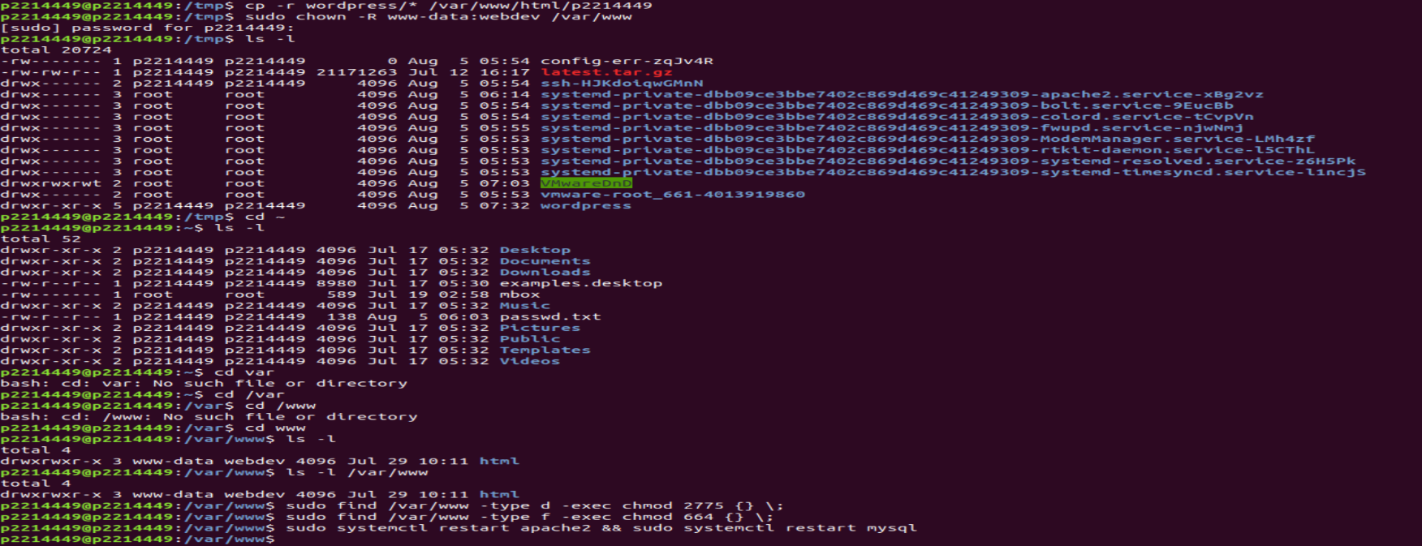

Monitor the latest 20 log entries of the log files generated by Ubuntu server.

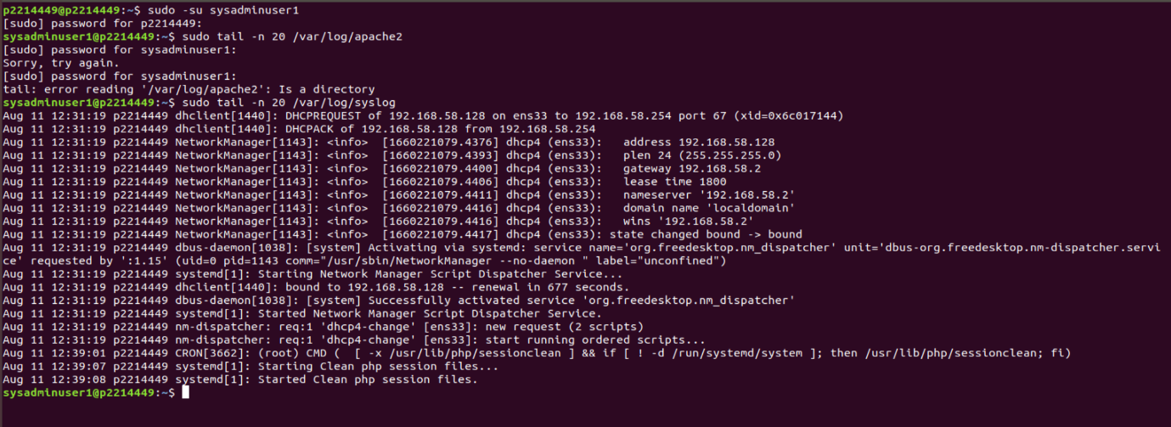

Change the owner and primary group of the log file /var/log/apache2

Monitor the latest 20 log entries of the log files generated by Apache server. (latest 10 files in error.log and latest 10 files in error.log.1)

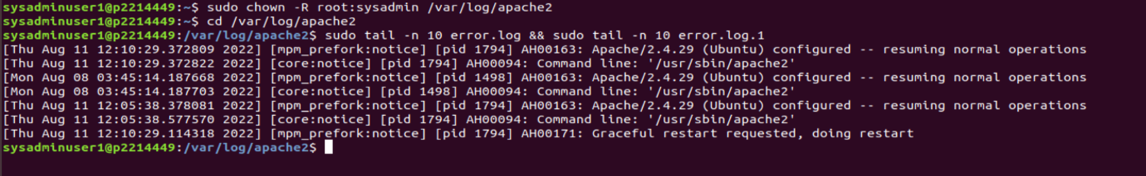

Change the owner and primary group of the log file /var/log/MySQL

Monitor the latest 20 log entries of the log files generated by MySQL server.

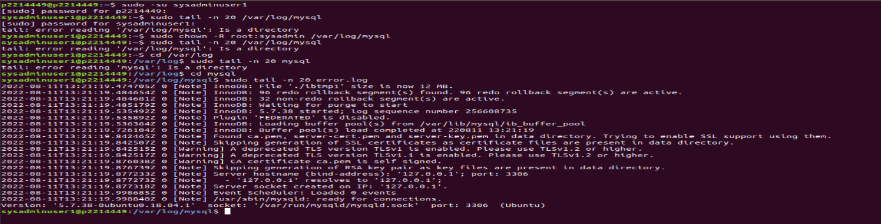

Issues Faced:

* Problem faced: Account cannot use sudo command
* Account does not have sudo privileges
* To resolve it, just add it to the sudo group with sudo usermod -aG sudo pxxxxxxx

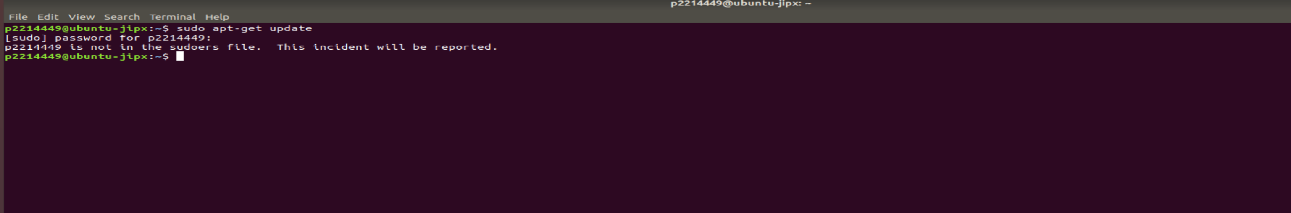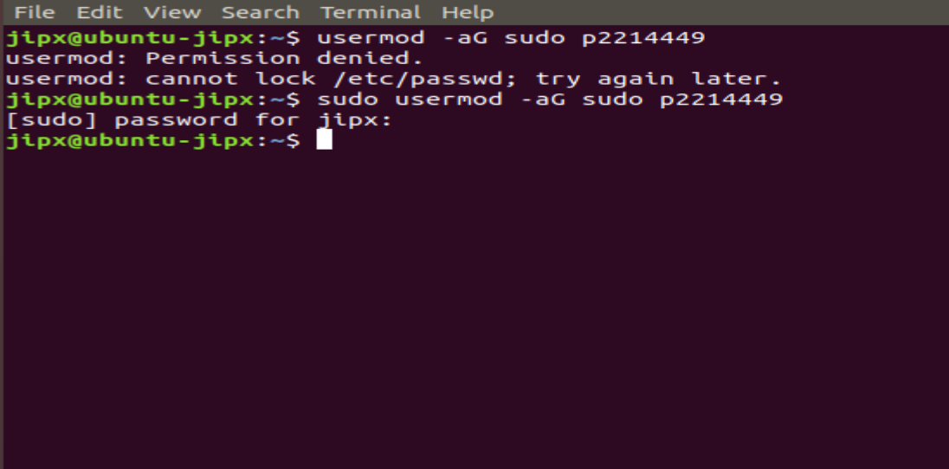

* Problem faced: /etc/sudoers is a read only file, I cannot edit the file to ensure that the sysadmin group can execute any command
* To resolve it, change the file permissions, allowing users to read and write, as well as, groups and owners to read only.

